Procedure Summary:
Detailed steps to select and export your Geographic Area of Concern as part of your ITQ application.
Definitions/Acronyms:
Acronym | Definition
OCIO | Office of the Chief Information Officer (Iowa)
ITQ | Intent to Qualify
Geographic Area of Concern | Area identified by a community as needing broadband services.
Selection Tool | Mechanism to select the Geographic Area of Concern on the Iowa Broadband Map V5.
IA Grants Online | State of Iowa’s grant management system, utilized to submit an application to this ITQ.
CSV File | Comma Separated Value file

Procedure Steps:
- Access and Navigation
  - Access the Selection Tool here: https://iowa.maps.arcgis.com/apps/webappviewer/index.html?id=f454e1dd4e1c405787b5f35c56bcfee3
  - Tools at top-left of screen
    - Zoom in and out (this can also be done by scrolling up/down on a mouse wheel)
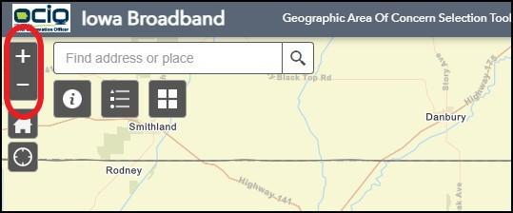

    - Home – This button zooms you out to default view.
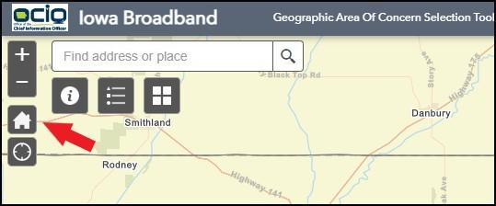
    - Search Bar – Can be used to search for a location on the map.
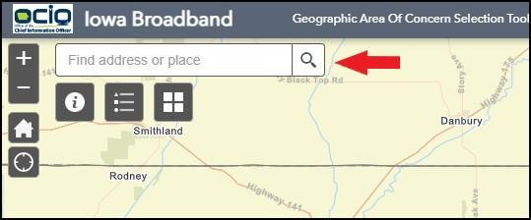
    - My Location – This requires allowing access to your location through your browser and will take you to your location on the map.
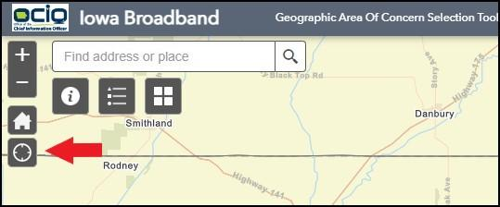
    - Instructions – written version of Selection Tool instructions
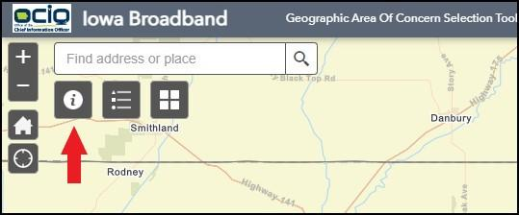
    - Legend – Defines the “dots” you see on the map
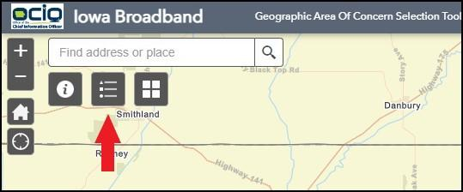
    - Base map Gallery – Used to change the map view
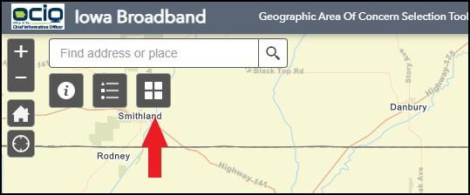
- Identify and Select your Geographic Area(s) of Concern
  - The Selection Tool will populate a circle around the center of your Geographic Area of Concern.
  - Identify the center of your project by clicking on one of the eligible or non-eligible locations near the center of your Geographic Area of Concern. You may also use the Search Bar or the My Location button to find an address on the map (See 1.b.iii and 1.b.iv above).
  - Click the 3 dots (…) at the bottom-right of the pop-up window
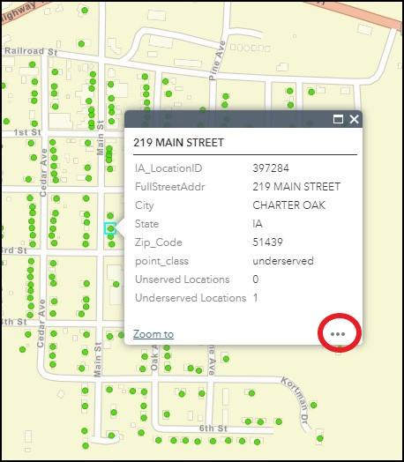
  - Click “Set Location”
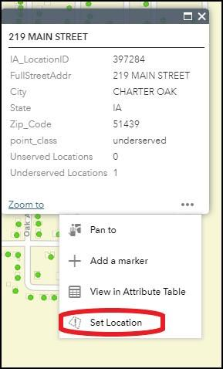
You will now see the default circle populate on screen (2 mile radius).
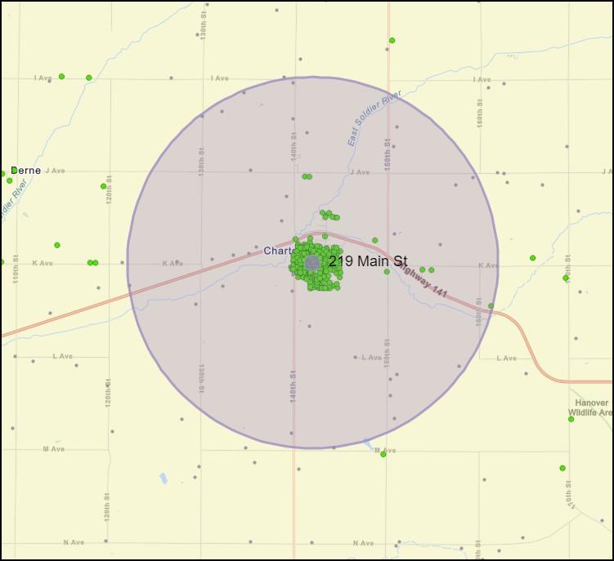
  - At the bottom of the screen, you will now see some tabs.
  - The Adjust Radius Distance Tab allows you to modify the size of the circle on-screen. You may use the up/down arrows to adjust in 1-mile increments or populate the desired radius distance in the box. Hit Enter or click anywhere on the map to initiate this change.
    - Note the minimum radius is ¼ mile and the maximum radius is 8 miles (approximately 200 square miles)
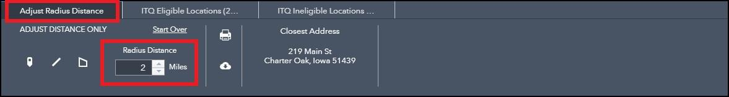
  - Should you want to reset and drop a new pin, click Start Over, which will clear the existing circle on-screen.
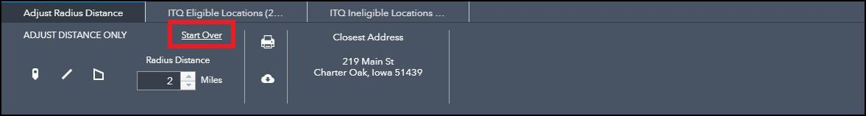
DO NOT USE the tools at the bottom-left to “draw” your area. Instead, click a location on the map (See step 2.b above). These will not result in a successful export of your Geographic Area of Concern. Follow the steps within this document to select and export your Geographic Area of Concern.
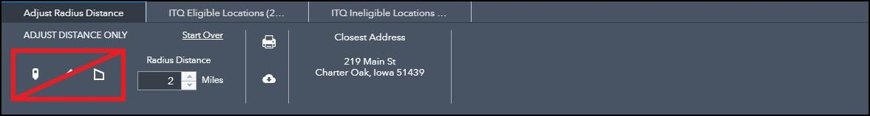
  - Once satisfied with your Geographic Area of Concern, there are a couple pieces of information you will need to record that will later be populated in IA Grants Online. This will allow the Office to generate the exact Geographic Area of Concern for use in future funding opportunities.
    - Write down the address displayed on the Adjust Radius Distance Tab. If the full address is not listed (street, city, state, ZIP) follow Part B, step 1 of from the Instructions button on the map (See 1.b.v above).
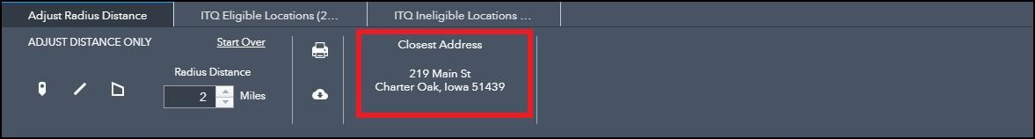
    - Write down the radius distance used to create your circle.
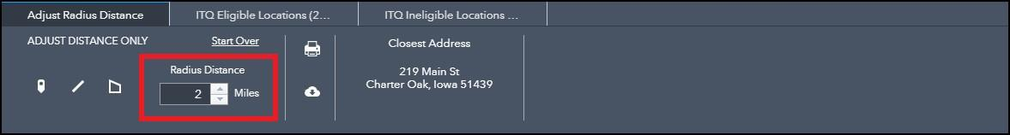
  - You are now ready to export the location information of your selected Geographic Area of Concern.
    - Click on the ITQ Eligible Locations Tab. You will see the number of unserved and underserved locations within your Geographic Area of Concern.
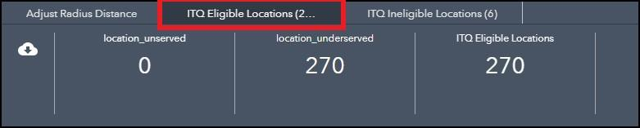
    - Click the download icon to export a CSV file (list of locations) that will be uploaded to IA Grants Online as part of your ITQ application.
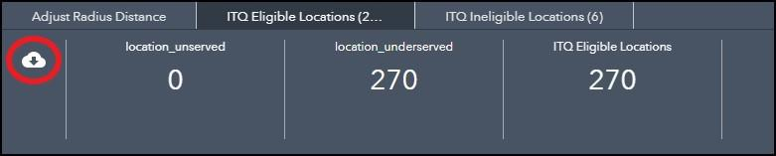
- Follow steps in Exhibit C - Iowa Grants Registration and Application Instructions to upload your CSV File(s) to your ITQ application.

Resources:
Iowa Grants Online Login: IowaGrants
Iowa Grants Online Account Creation/Initial login since December 12, 2022 (system updates made) Imperative to follow instruction exactly: External Login Instructions | Iowa Department of Management
Iowa Grants Registration and Application Instructions (Exhibit C): https://ocio.iowa.gov/empower-rural-iowa-broadband-grant-program-broadband-intervention-zones-invitation-qualify-001
Geographic Area of Concern Selection Tool video: https://youtu.be/t3fQjtvznyc

