Region 7 Fall Forum Blog Post #1

Region 7 State/EPA Process Improvement Network Fall Forum

Flashback to December 2014: Region 7 was hosting the biannual Four State Director meeting which included senior level management from Region 7 and each of the four States (Iowa, Kansas, Missouri, and Nebraska). The agenda included a session titled “Lean and Process Improvement” which created a buzz in the room and produced a number of sidebar conversations. It became clear that we, Region 7 and the States, had a great opportunity to partner on process improvement efforts. Three months later, we held our very first R7 State/EPA Process Improvement Network call.

The States and R7 each have one or two people who participate on the Network and we meet bi-monthly to discuss a variety of topics related to process improvement. With each Agency having process improvement programs at different levels of size and experience, we are all benefiting from the increased collaboration. Some of the ways we are partnering include: sharing information and resources such as forms, templates, and Lean techniques; discussing best practices for Lean programs and events; providing shadowing and facilitating opportunities; and conducting Lean training events that are relevant and open to the Network.

During the course of the bi-monthly calls, the Network decided that an in-person meeting would be beneficial. We had also discussed the need for training opportunities to learn more about Lean. Iowa, whose robust process improvement program is over a decade old, offered to host a Fall Forum for the Network. The four-day, in-person gathering included training on several process improvement topics, structured networking events, and a half-day Network meeting. Twenty employees from EPA and the States attended the event (look for a blog from a State’s perspective to post soon). The training was excellent and provided a lot of information that we can use to make our Region 7 Process Excellence Team even more effective. Since the Fall Forum, we’ve seen more shadowing, facilitation, and training opportunities coming from the Network, which will play a key role in helping facilitators from across the region get the experience they need to become great process improvement practitioners.

If you would like to hear more about Region 7’s State/EPA Process Improvement Network or the Fall Forum that was held in December 2015, please contact Jonathan Cooper at 913-551-7287 or cooper.jonathan@epa.gov.

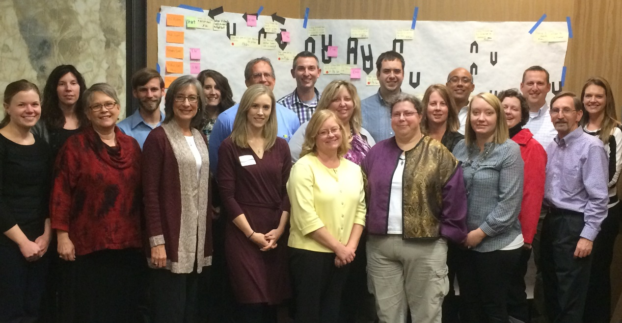
Fall Forum Group Photo

